|  |  |  |  |  |
| --- | --- | --- | --- | --- |
|  |  |  |  | **“TASDIQLAYMAN”**  Namangan viloyati hokimi  ___________ Sh.Sh.Abdurazakov    “___” ___________ 2023-yil |
| **“KELISHILDI”**  Namangan viloyati  hokimi o‘rinbosari  ___________ G‘.S.Murodxujayev    “___” ___________ 2023-yil |  | **“KELISHILDI”**  Namangan viloyati ichki ishlar  boshqarmasi boshlig‘i  ___________ Sh.N.Rahmonov    “___” ___________ 2023-yil |  | **“KELISHILDI”**  Milliy gvardiyaning Namangan viloyati bo‘yicha boshqarmasi boshlig‘i  ___________ S.M.Mirzayev    “___” ___________ 2023-yil |
| **“KELISHILDI”**  Namangan davlat  universiteti rektori  ___________ S.T.Turg‘unov    “___” ___________ 2023-yil |  | **“KELISHILDI”**  Namangan muhandislik-qurilish  instituti rektori  ___________ Sh.T.Ergashev    “___” ___________ 2023-yil |  | **“KELISHILDI”**  Namangan muhandislik-texnologiya  instituti rektori  ___________ O.O.Mamatkarimov    “___” ___________ 2023-yil |
| **“KELISHILDI”**  Yoshlar siyosati va sport vazirligi  Namangan viloyati boshqarmasi boshlig‘i  ___________ A.N.Tuychiyev    “___” ___________ 2023-yil |  | **“KELISHILDI”**  O‘zbekiston Respublikasi raqamli texnologiyalar vazirligining Namangan viloyati hududiy boshqarmasi boshlig‘i  ___________ X.B.Boboxonov    “___” ___________ 2023-yil |  | **“KELISHILDI”**  Oliy ta’lim, fan va innovatsiyalar vazirligi huzuridagi Bilim va malakalarni baholash agentligi Namangan viloyati  bo‘limi boshlig‘i  ___________ B.X.Abdulxafizov    “___” ___________ 2023-yil |

**TEST O‘TKAZILADIGAN BINO (SEKTOR) VA GURUHLARNING REJA-CHIZMASI**

**TEST O‘TKAZILADIGAN BINO (SEKTOR) VA GURUHLARNING JOYLASHISHI HAQIDA MA’LUMOT**

|  |  |  |
| --- | --- | --- |
| **1** | **Davlat test markazi Namangan viloyati bo‘limi binosi** | **1080 ta o‘rin** |
| **2** | **“Barkamol avlod” sport majmuasi** | **1080 ta o‘rin** |
| **3** | **Namangan muhandislik-qurilish instituti akademik liseyi** | **480 ta o‘rin** |

**Binolar soni: 3 ta Jami guruhlar soni: 88 ta Jami o‘rinlar soni: 2640 ta**

Test sinovlari o‘tkaziladigan muassasalar manzili: 1. Davlatobod tumani, Yuksalish MFY

2. Namangan shahar, Istiqlol ko‘chasi 3-uy

3. Yangi Namangan tumani, Islom Karimov ko‘chasi 12-uy

**Davlat test markazi Namangan viloyati bo‘limi binosi**

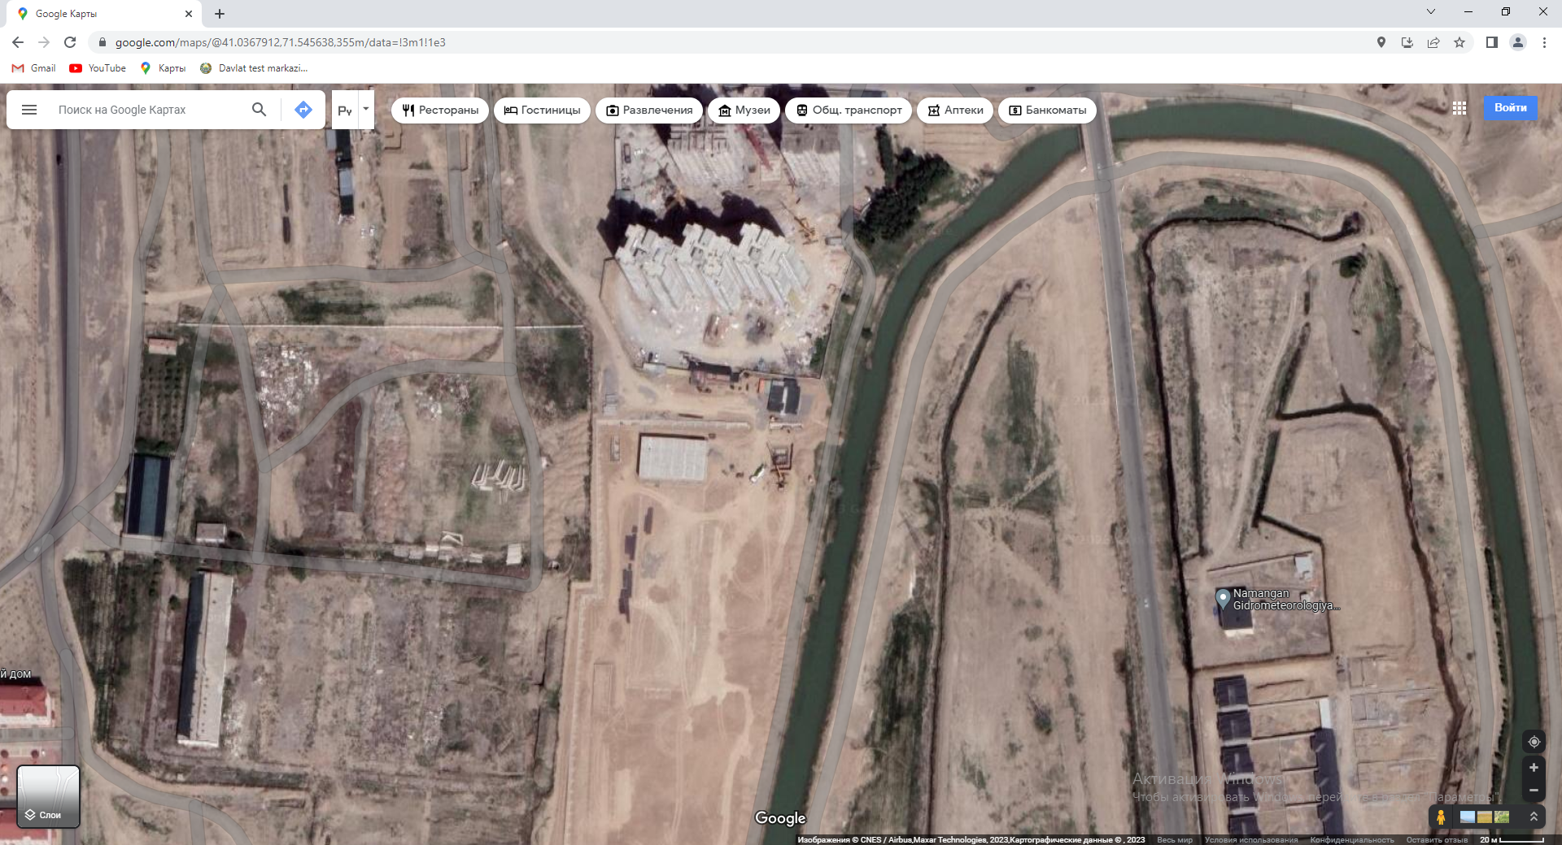

**1-BINO**

**Geolokasiya - https://yandex.uz/maps/-/CCUv7DElsB**

**https://goo.gl/maps/7sXa87YkNSGVqUrF8**

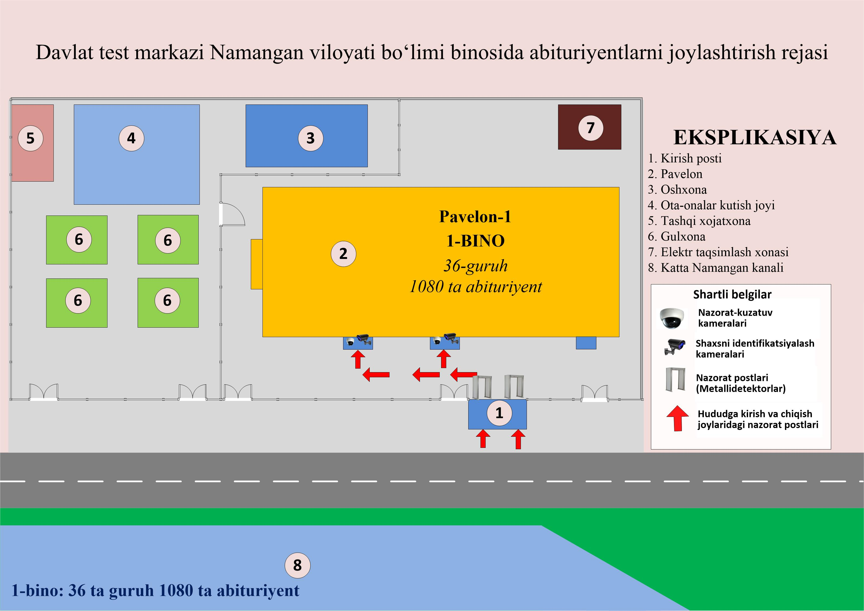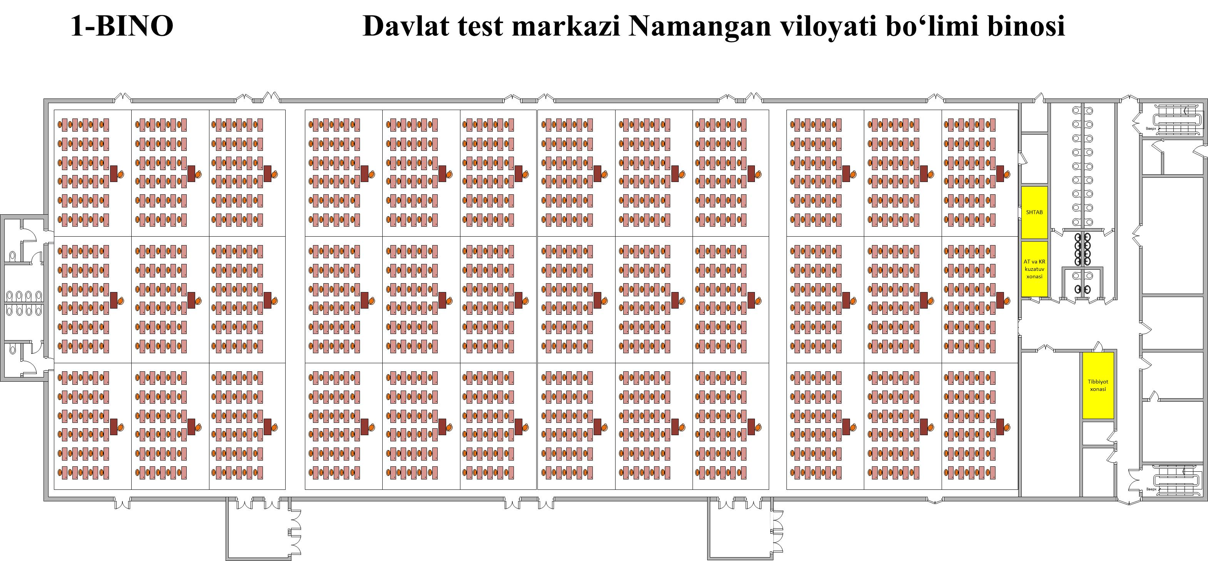

|  |  |  |  |  |  |  |
| --- | --- | --- | --- | --- | --- | --- |
| **Bino raqami** | **Bino o‘lchami** | **Bino maydoni** | **Abituriyentlar o‘tqaziladigan maydon o‘lchami** | **Abituriyentlar o‘tqaziladigan maydon** | **Guruhlar soni** | **Jami abituriyentlar o‘tiradigan joy** |
| 1 | Bo‘yi – 96,8 m  Eni – 30 m | 2906,8 m2 | Bo‘yi – 95 m  Eni – 30 m | 2850 m2 | 36 ta | 1080 ta |

**Test sinovlari o ‘tkaziladigan muassasa rahbari:___________________________________________“Barkamol avlod” sport majmuasi**

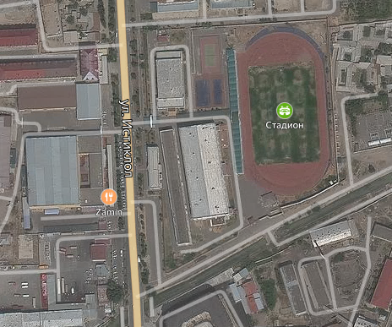

**2-BINO**

**Geolokasiya -** [**https://yandex.uz/maps/-/CCUQqHteCC**](https://yandex.uz/maps/-/CCUQqHteCC)

[**https://goo.gl/maps/HfA88Lur3Ppw4LzV9**](https://goo.gl/maps/HfA88Lur3Ppw4LzV9)

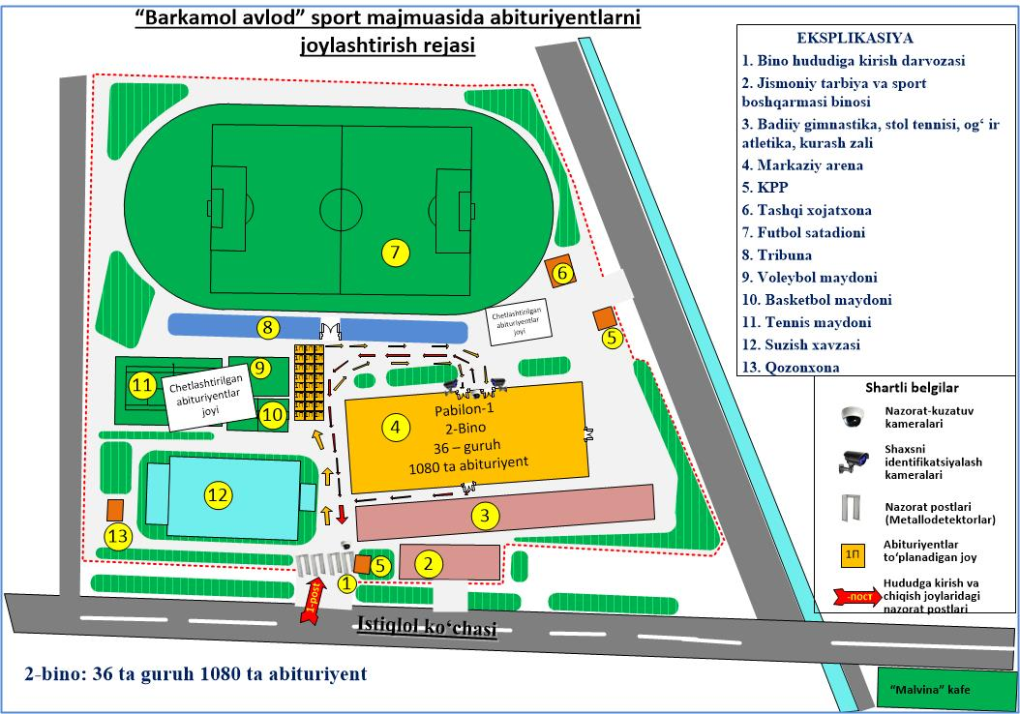

**Test sinovlari o ‘tkaziladigan muassasa rahbari:___________________________________________**

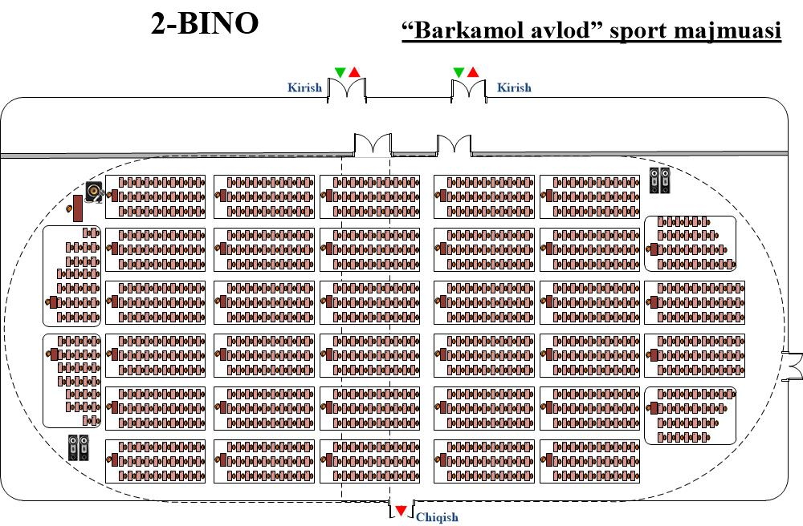

|  |  |  |  |  |  |  |
| --- | --- | --- | --- | --- | --- | --- |
| **Bino raqami** | **Bino o‘lchami** | **Bino maydoni** | **Abituriyentlar o‘tqaziladigan maydon o‘lchami** | **Abituriyentlar o‘tqaziladigan maydon** | **Guruhlar soni** | **Jami abituriyentlar o‘tiradigan joy** |
| 2 | Bo‘yi – 100 m  Eni – 40 m | 4000 m2 | Bo‘yi – 86 m  Eni – 28,5 m | 2408 m2 | 36 ta | 1080 ta |

**Test sinovlari o ‘tkaziladigan muassasa rahbari:___________________________________________**

**Namangan muhandislik-qurilish instituti akademik liseyi**

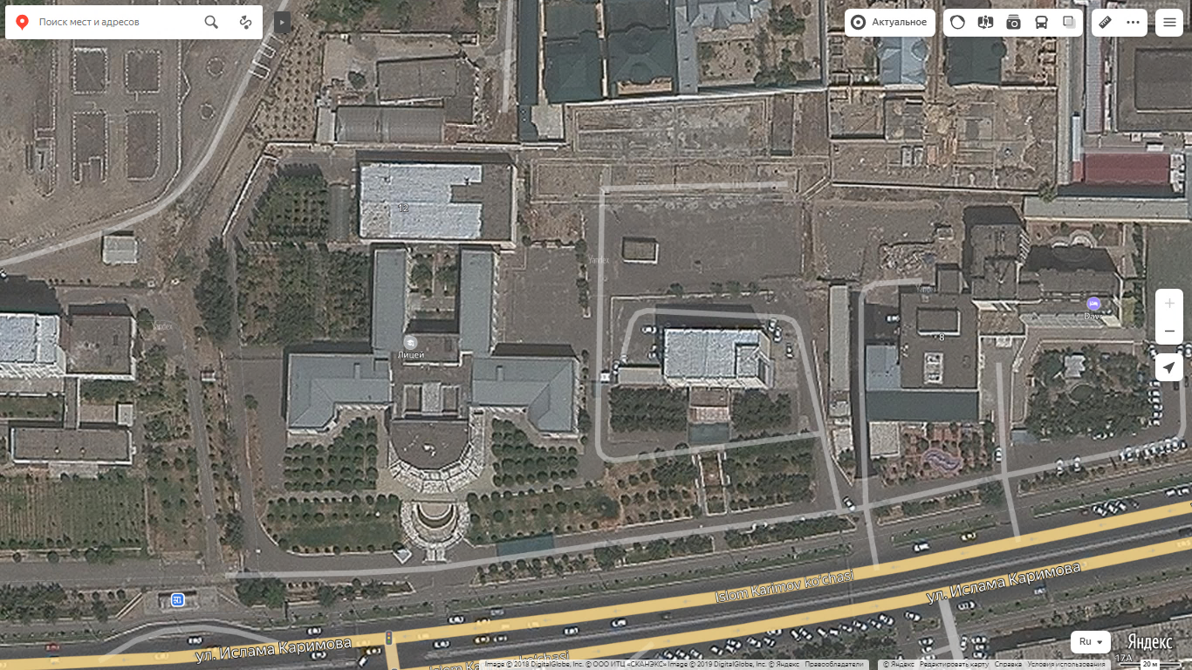

**3-BINO**

**Geolokasiya -** [**https://yandex.uz/maps/-/CCUQuQuVDC**](https://yandex.uz/maps/-/CCUQuQuVDC)

[**https://goo.gl/maps/CuFHj4wYvu2TGp3p6**](https://goo.gl/maps/CuFHj4wYvu2TGp3p6)

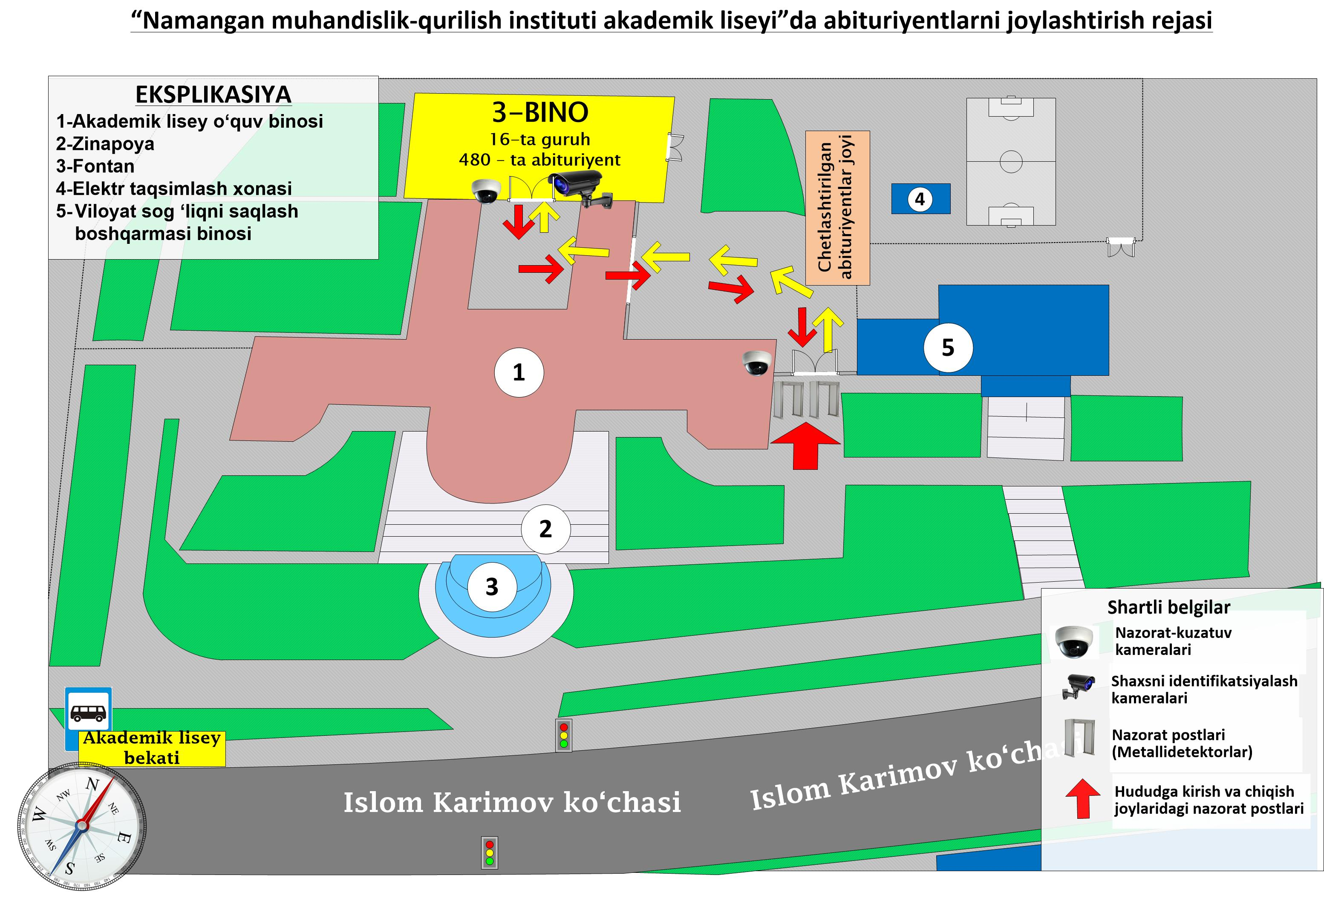

**Test sinovlari o ‘tkaziladigan muassasa rahbari:___________________________________________**

**3-BINO. Namangan muhandislik-qurilish instituti akademik liseyi**

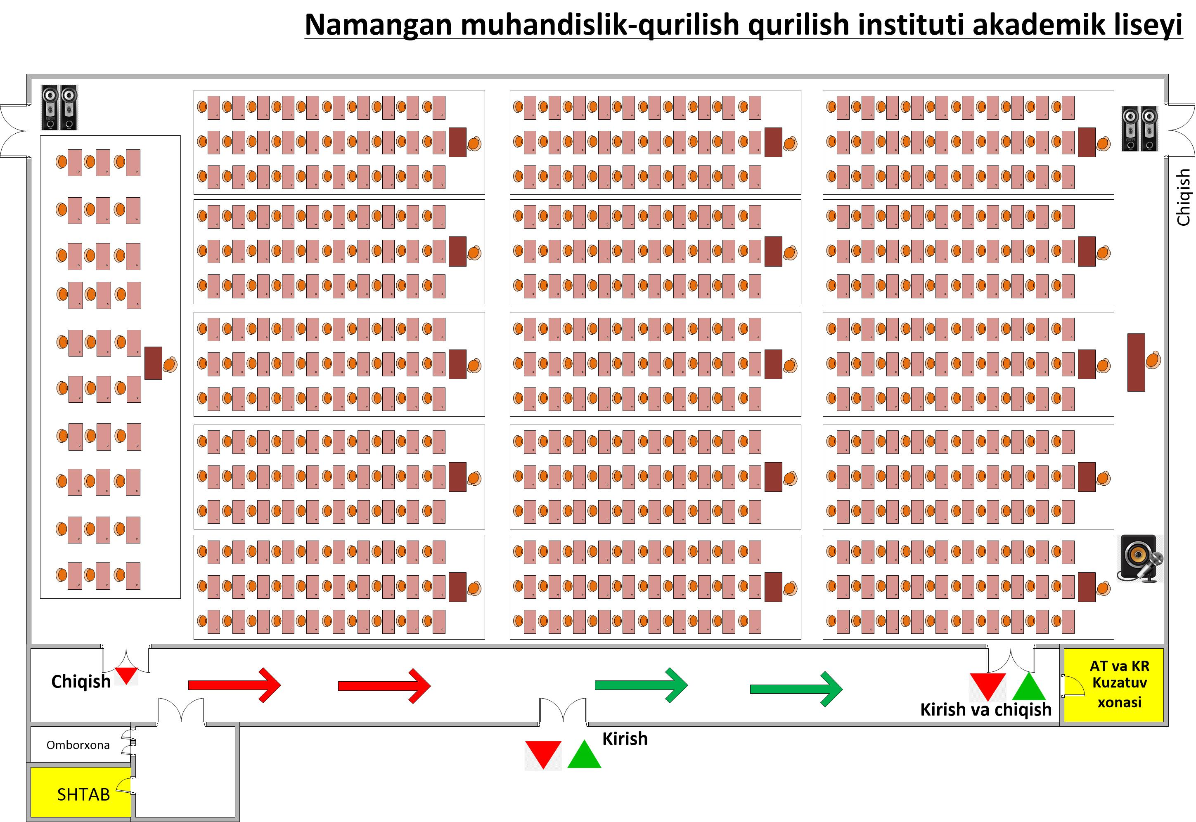

|  |  |  |  |  |  |  |
| --- | --- | --- | --- | --- | --- | --- |
| **Bino raqami** | **Bino o‘lchami** | **Bino maydoni** | **Abituriyentlar o‘tqaziladigan maydon o‘lchami** | **Abituriyentlar o‘tqaziladigan maydon** | **Guruhlar soni** | **Jami abituriyentlar o‘tiradigan joy** |
| 3 | Bo‘yi – 50 m  Eni – 25,5 m | 1275 m2 | Bo‘yi – 48 m  Eni – 24 m | 1152 m2 | 16 ta | 480 ta |

**Test sinovlari o ‘tkaziladigan muassasa rahbari:___________________________________________**